

**Mess Management**

**Project**

**VAISHNAVI**

**JAIN**



**Introduction**



A Mess Management System helps a hostel maintain:

Student Record

Mess Attendance

Daily meal count

Monthly bill calculation

Extra items charge (milk, eggs, special meals)

Automated summary and reporting



**Algorithm**



**Algorithm Steps :**

**Start**

**Display menu**

**If user selects Add student : - Enter Student details - Store in list**

**If user selects Mark Attendance : - Select student**

**- Add today’s meal count**

**If user selects Update Extra items: -Add extra charges**

**If user selects Generate Bill: - For each student {Bill - mess rate * attendance days + extra charges}**

**If user selects Exit : - Stop**

**End**



**Flowchart**

**START**

**Display Menu**

**User Choice**

**Add Student** **Attendance Marking**

**Extra Items**

**Generate Bill**

**EXIT**



**Python**

**Program**

22/11/2025, 14:52 Python Project - Colab

* Mess Management System for Hostel students = {}

def add_student():

roll = input("Enter Roll Number: ")

name = input("Enter Student Name: ")

students[roll] = {"name": name, "attendance": 0, "extras": 0}

print("Student added successfully!\n")

def mark_attendance():

roll = input("Enter Roll Number: ")

if roll in students:

students[roll]["attendance"] += 1

print("Attendance marked!\n")

else:

print("Student not found!\n")

def add_extra_items():

roll = input("Enter Roll Number: ")

if roll in students:

amt = float(input("Enter extra amount: "))

students[roll]["extras"] += amt

print("Extra amount added!\n")

else:

print("Student not found!\n")

def generate_bill():

mess_rate = 80 # per meal/day

print("\n----- Monthly Mess Bill -----")

for roll, data in students.items():

bill = data["attendance"] * mess_rate + data["extras"]

print(f"{data['name']} ({roll}) → Rs. {bill}")

print("------------------------------\n")

while True:

print("1. Add Student")

print("2. Mark Attendance")

print("3. Add Extra Items")

print("4. Generate Bill")

print("5. Exit")

choice = input("Enter your choice: ")

if choice == "1":

add_student()

elif choice == "2":

mark_attendance()

elif choice == "3":

add_extra_items()

elif choice == "4":

generate_bill()

elif choice == "5":

print("Exiting system...")

break

else:

print("Invalid choice!\n")

1. Add Student
2. Mark Attendance
3. Add Extra Items
4. Generate Bill
5. Exit

Enter your choice: 1

Enter Roll Number: 101

Enter Student Name: Vaishnavi Jain

Student added successfully!

1. Add Student
2. Mark Attendance
3. Add Extra Items
4. Generate Bill
5. Exit

Enter your choice: 2

Enter Roll Number: 101

Attendance marked!

1. Add Student
2. Mark Attendance
3. Add Extra Items
4. Generate Bill
5. Exit

https://colab.research.google.com/drive/1e2m-FeHjdULSlY5SsKbad8PA6gbOVPMV#scrollTo=eJhWTuYaGODg&printMode=true 1/2

22/11/2025, 14:52 Python Project - Colab

Enter your choice: 3 Enter Roll Number: 101 Enter extra amount: 50

Extra amount added!

1. Add Student
2. Mark Attendance
3. Add Extra Items
4. Generate Bill
5. Exit

Enter your choice: 4

----- Monthly Mess Bill -----

Vaishnavi Jain (101) → Rs. 130.0

------------------------------

1. Add Student
2. Mark Attendance
3. Add Extra Items
4. Generate Bill
5. Exit

Enter your choice:

https://colab.research.google.com/drive/1e2m-FeHjdULSlY5SsKbad8PA6gbOVPMV#scrollTo=eJhWTuYaGODg&printMode=true 2/2



**Sample**

**Database**



 **id: Unique student ID**

 **name: Student’s name**

 **room: Room number in Hostel**  **meals: Number of meals taken (or remaining based on your system)**



**Sample File**

**Structure**

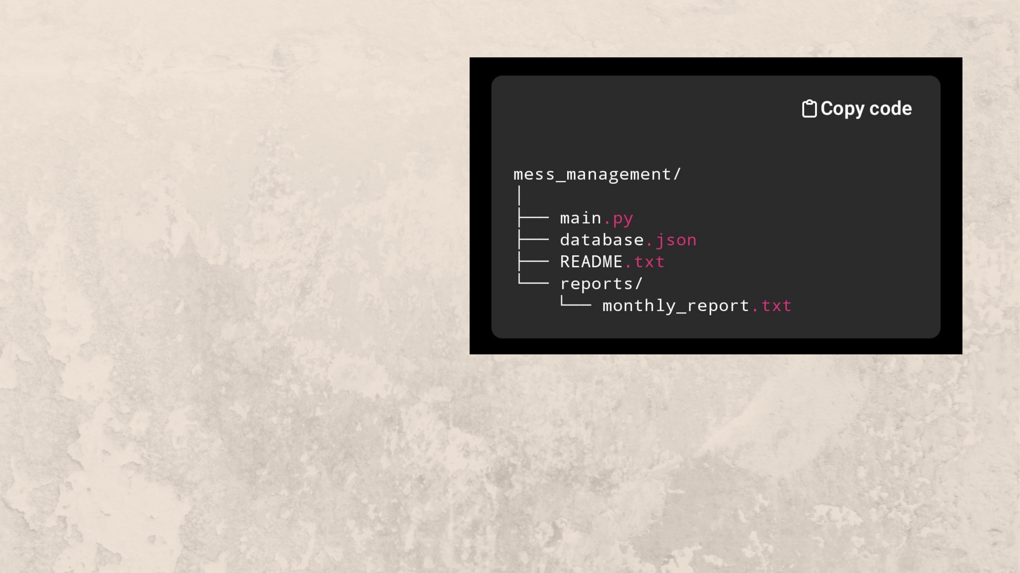

 main.py  databse.json  README.txt

reports/

 monthly_report.txt



**Conclusicon**



The Mess Management System:

Automates student meal tracking

Reduces manual work

Stores data safely

Generates quick bills

Suitable for real college hostel use



**THANKYOU**